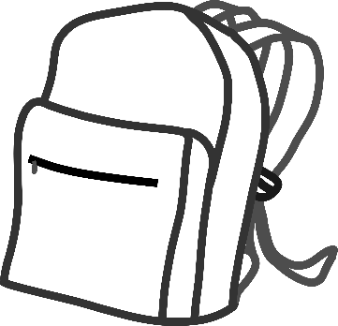 |  | 
 | 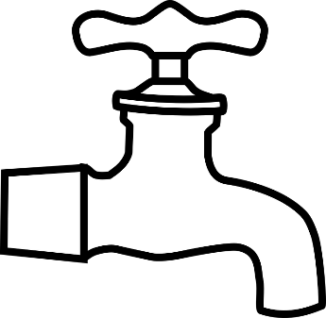 | 
 |  | 

bag | tap | bat
pen | dig | cat
leg | net | pig

Your child has shown they are ready to start to try to read simple words.
How to read a word.
- Cut out the words and pictures.
- Put a sound button under each letter. This is a dot drawn underneath each letter and will help your child to say each sound in turn. E.g. m a p
- If your child cannot remember a sound then do tell them, here is a link, which demonstrates how to say each sound (phoneme) correctly. It is important to say it clearly.
https://www.youtube.com/watch?v=BqhXUW_v-1s

- Repeat each sound in turn a few times. Your child may roll their arms to blend the word together; this is a technique we use in school.
- Read each word a few times to increase fluency and confidence.
- If your child struggles, then cut out the pictures and use these to help your child match the picture to a word.
- The aim is for your child to build confidence and succeed. So keep practicing these words and praise your child.
- Little and often is key, one or two words a day is fine.
- Please email me if I can help in anyway.

