How to help your child to remember their phase 2 phonemes (sounds).
Here is a link to help you with the correct pronunciation
https://www.youtube.com/watch?v=BqhXUW_v-1s
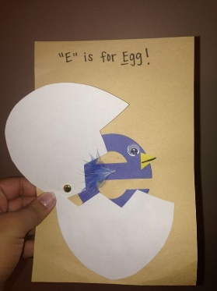
Make flash cards together, here are some ideas:
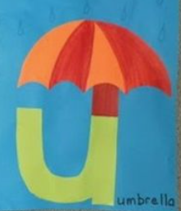
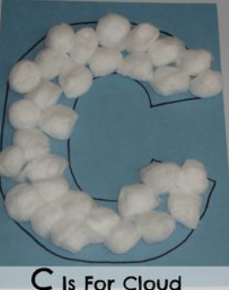

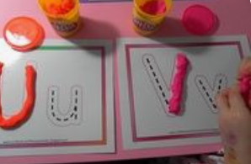
Use playdough to make the letter.

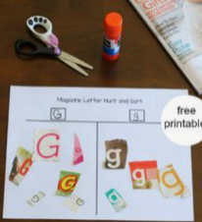
Find the letter in a magazine and cut it out.

Write the letter out a number of times and hide them around the house, how many can your child find? Remember to keep repeating the phoneme (sound).
Write the sound on a toy, block, peg, conker or anything. Encourage your child to hide it for you to find. Remember to encourage your child to say the phoneme.
Look for the sound in their favourite book. How many can they find on a page? Say the phoneme (sound) together. Are there more or fewer on the next page?

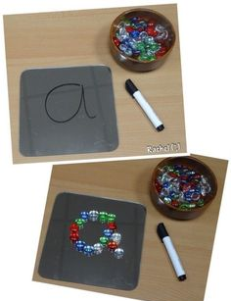
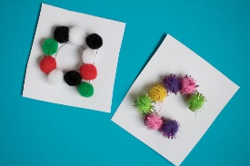

Write the grapheme (written sound), encourage your child to say it and then cover it with counters, pasta shapes or other small objects.

Play the fastest finger using the sound mat provided. Can you point to the ‘a’, now the ‘t’ etc.

