Some ideas for some phonic games to play at home
Pairs
Make 2 sets of each sound your child needs to practice. Turn them over and can you find a pair?

Write a word and then draw a picture to match the word. You can do this with your child. Turn them over and play pairs.

Run Around
Put up 5 different digraphs around the room. Say the sound and can your child move to that sound. Swap roles can your child say the sound for you to move to?

Phoneme Islands
What you’ll need: cushions, paper, pen
What to do:
1. Scatter cushions on the floor around a room. These are your islands!
2. On separate pieces of paper, write big, phase 3 sounds (e.g. ai, igh, oo, oa, etc). Pop a digraph or trigraph on each cushion.
3. Shout out the sound, and see if your little one can run to the ‘island’ with that letter!

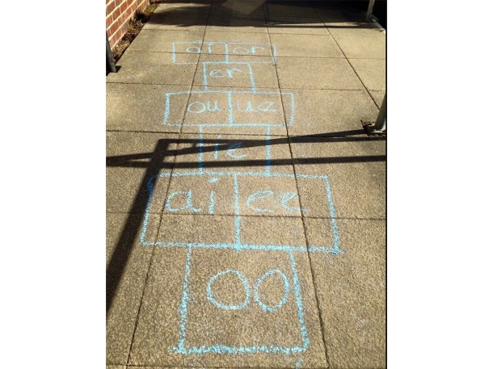
Play phonic hopscotch
Say the sound as the stone you throw lands on it.

Phonic word relay
Write out a set of digraphs, trigraphs or words with a sound your child needs to practice. Place them in a bucket at a finishing line. Your child can run, hop or skip to collect a word or a sound. Bring it back and read the word or say the sound. Then repeat.
You could focus on 4 different sounds (e.g. ai, ee, igh, oa). Write each diagraph on a piece of paper, repeat so you have each sound a number of times on different pieces of paper. Place these in a bucket at the finish line as above. Your child collects a sound, says it and sorts it into the correct pot at the end.

Time challenge
How many words or sounds can they say in 1 minute?
Write some words or sounds on pieces of paper. Set a timer and see how many can be said or read. Repeat daily using the same words and gradually adding more as they improve.
Lucky dip
Hide a picture or word in an envelope in a bucket with some shredded paper. Can they find an envelope and read that word, or if it is a picture write the word to go with it?
Soak the sounds
If you have a water pistol or a super soaker and the weather is kind. Chalk the sounds or words onto the path and your child can soak the word as they read. Or throw a wet sponge onto the sound you say.
Sound hunt
Write up to 10 sounds which spell words (e.g. ch, o, p, s, n, sh, i, ck, u, a) suitable for your child on little bits of paper, choosing different-coloured paper or pens. Hide them indoors or outdoors. Let your child know which colour sounds they are hunting for. The aim is for them to find all the sounds and then to make as many different real or nonsense words as they can with their sounds. They could also write down the words they make as an extra challenge.
Keepy uppy
Blow up a balloon and write the sound your child is practicing on the balloon. Every time they touch the balloon they say the sound.

Sound and spoon race
Gather as many small ball pool or ping-pong balls as you can and write sounds that your child is learning on them. Put these balls in their starting places on a start line. Place a bowl or bucket for your child at the finish line. The aim is for the children to use their spoons to carry their sound balls to the finish line without dropping or holding them. When they get to the end, they should drop it into the bucket while shouting the sound out. Continue until all the sounds are in the buckets.

Sound slam dunk
Peg pillowcases on a washing line so that they hang open like nets, you may need to roll down the top of the pillow cases to make them stay open. Label large balls with sounds your child is learning. The aim is to shoot them or slam dunk them into the nets while shouting out the sounds as they score. After the game they could empty each net and make a word with the balls before playing again.

