Some ideas for practising sounds at home
Useful phonic websites
https://www.youtube.com/watch?v=BqhXUW_v-1s
the correct pronunciation phase 2 and 3

https://www.oxfordowl.co.uk/for-home/advice-for-parents/phonics-videos

https://www.phonicsplay.co.uk/freeIndex.htm
some free phonic and reading games

Pairs
Make 2 sets of each sounds your child needs to practice. Turn them over and can you find a pair?

Write a sound and then draw a picture that begins with the same sound. Can they find the pairs – the picture with the initial sound.

Run Around
Put up the different sounds around the room. Say the sound and can your child move to that sound. Swap roles can your child say the sound for you to move to?

Phoneme Islands
What you’ll need: cushions, paper, pen
What to do:
1. Scatter cushions on the floor around a room. These are your islands!
2. On separate pieces of paper, write big, phase 2 sounds they have covered. See the notes home
3. Shout out the sound, and see if your little one can run to the ‘island’ with that letter!

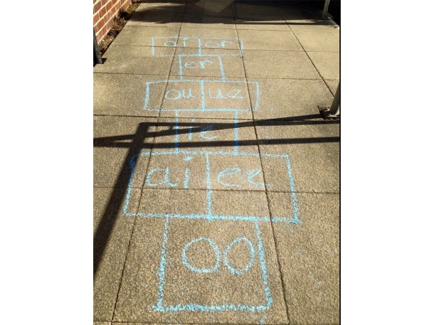
Play phonic hopscotch
Say the sound as the stone you throw lands on it.

Phonic word relay
Write out a set of sounds or words starting with a sound your child needs to practice. Place them in a bucket at a finishing line. Your child can run, hop or skip to collect a word or a sound. Bring it back and say the sound. Then repeat.
Lucky dip
Hide a picture or sound in an envelope in a bucket with some shredded paper. Can they find an envelope and say that sound, or if it is a picture say the initial sound?

Soak the sounds
If you have a water pistol or a super soaker and the weather is kind. Chalk the sounds onto the path and your child can soak the word as they read. Or throw a wet sponge onto the sound you say.
Keepy uppy
Blow up a balloon and write the sound your child is practicing on the balloon. Every time they touch the balloon they say the sound.

Sound and spoon race
Gather as many small ball pool or ping-pong balls as you can and write sounds that your child is learning on them. Put these balls in their starting places on a start line. Place a bowl or bucket for your child at the finish line. The aim is for the children to use their spoons to carry their sound balls to the finish line without dropping or holding them. When they get to the end, they should drop it into the bucket while shouting the sound out. Continue until all the sounds are in the buckets.

Sound slam dunk
Peg pillowcases on a washing line so that they hang open like nets, you may need to roll down the top of the pillow cases to make them stay open. Label large balls with sounds your child is learning. The aim is to shoot them or slam dunk them into the nets while shouting out the sounds as they score. After the game they could empty each net and make a word with the balls before playing again.

